Chapter 3, Solution 25

Consider the circuit shown below.

10
4
1
8
2
1
3
20
30
10
4
④
⓪
①
⓪
④
④
④
①
20
①
④
④

At node 1.
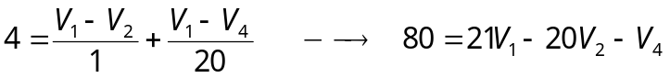 (1)
At node 2,
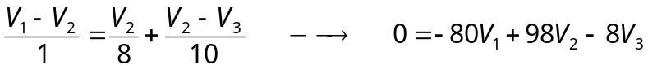 (2)

At node 3,
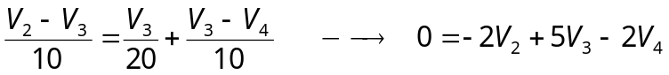 (3)
At node 4,
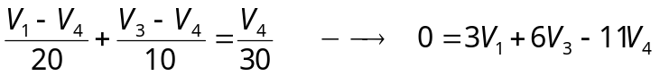 (4)
Putting (1) to (4) in matrix form gives:

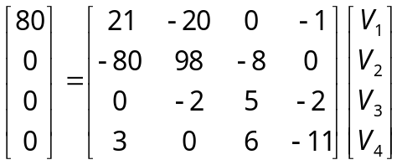

B = A V V = A⁻¹ B

Using MATLAB leads to

V₁ = 25.52 V, V₂ = 22.05 V, V₃ = 14.842 V, V₄ = 15.055 V

